from selenium import webdriver
from selenium.webdriver.common.by import By
import time

# Open browser (Selenium auto driver handling)
driver = webdriver.Chrome()

driver.maximize_window()

# Open login page
driver.get("https://practicetestautomation.com/practice-test-login/")
time.sleep(2)

print("TEST STARTED")

# ---------------------------
# TC_001 - VALID LOGIN
# ---------------------------
driver.find_element(By.ID, "username").send_keys("student")
driver.find_element(By.ID, "password").send_keys("Password123")
driver.find_element(By.ID, "submit").click()

time.sleep(2)

if "Logged In Successfully" in driver.page_source:
print("TC_001 Valid Login: PASS")
else:
print("TC_001 Valid Login: FAIL")

# Go back
driver.get("https://practicetestautomation.com/practice-test-login/")
time.sleep(2)

# ---------------------------
# TC_002 - INVALID LOGIN
# ---------------------------
driver.find_element(By.ID, "username").send_keys("wronguser")
driver.find_element(By.ID, "password").send_keys("wrongpass")
driver.find_element(By.ID, "submit").click()

time.sleep(2)

if "Your username is invalid" in driver.page_source:
print("TC_002 Invalid Login: PASS")
else:
print("TC_002 Invalid Login: FAIL")

# Close browser
driver.quit()

print("TEST COMPLETED")

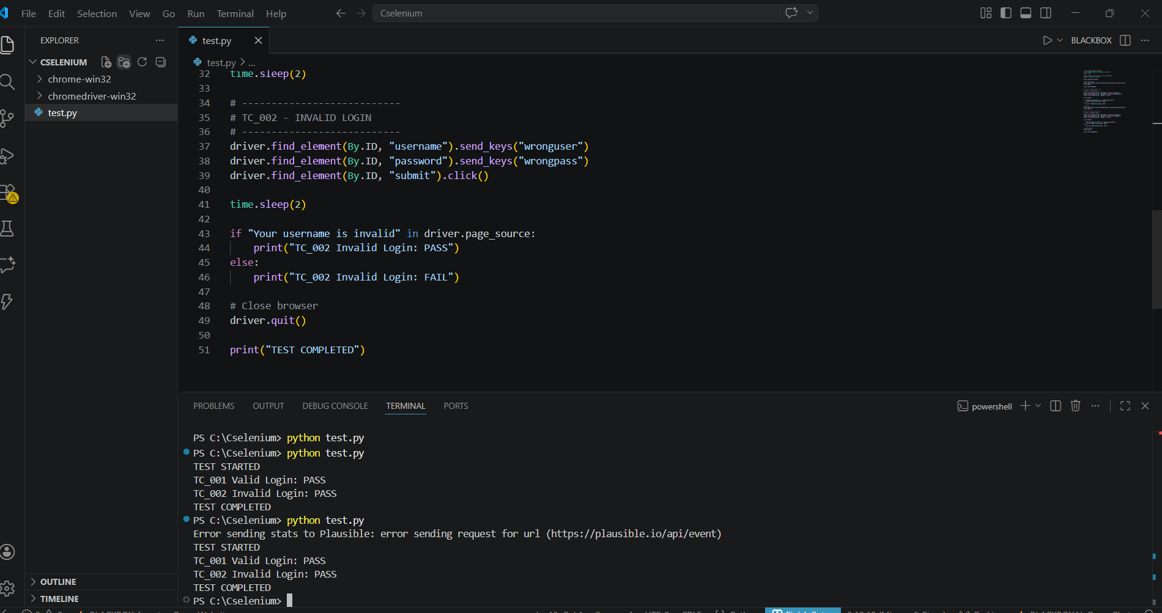

Chromewin 32
Chromedriver32
https://googlechromelabs.github.io/chrome-for-testing/#stable

